**Description**

Most of us are familiar with seeing URLs like [bit.ly](http://bit.ly/) or [t.co](http://t.co/) on our Twitter or Facebook feeds. These are examples of shortened URLs, which are a short alias or pointer to a longer page link. For example, I can send you the shortened URL <http://bit.ly/SaaYw5> that will forward you to a very long Google URL with search results on how to iron a shirt.

**Steps for setting up the environment**

* Clone from github.
* There will be 2 folder.
* Tinyurlspringboot is a spring boot application which consumes rest calls.
* Angular6-http-client is an angular application that consumes the rest calls.
* Setup postgresql.
  + Username: postgres
  + Password: 661745
* Create database with name tinyurlDB. Create a table with name url. Columns urlid(integer), shorturl (character varying 20 characters) , longurl(character varying 2000 characters), logdate (timestamp with time zone).

CREATE TABLE url(

urlid Integer,

shorturl char(50),

logurl char(2000),

logdate TIMESTAMPZ

);

* Open the Tinyurlspringboot folder in command prompt. Mvn clean install inside the spring boot application.
* Go to the angular application in command prompt and run ng serve.
* Go to the url link <http://localhost:4200/> .You will see the below page.
* Start the spring boot application as a Java application.
* 
* Put the long url in the text box and you will see a short url generated.
* 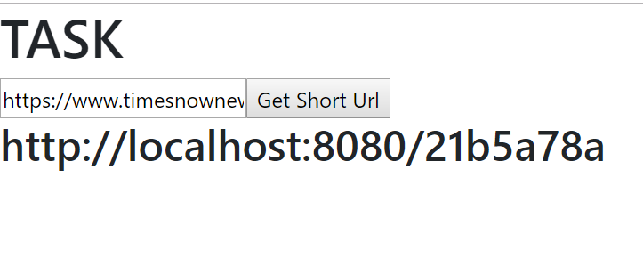
* Copy the short url to another tab in browser. You will see it re-directed to another tab in browser to the long url.

**REPORTS**

* The project has 88% coverage with Junits.
* The project has no major code quality violations.

**ANALYTICS**

For analytics, Elastic stack was used. The data from Postgresql was indexed to ES using Logstash. Visualization and Dashboard was created using Kibana.

**DASHBOARD:**

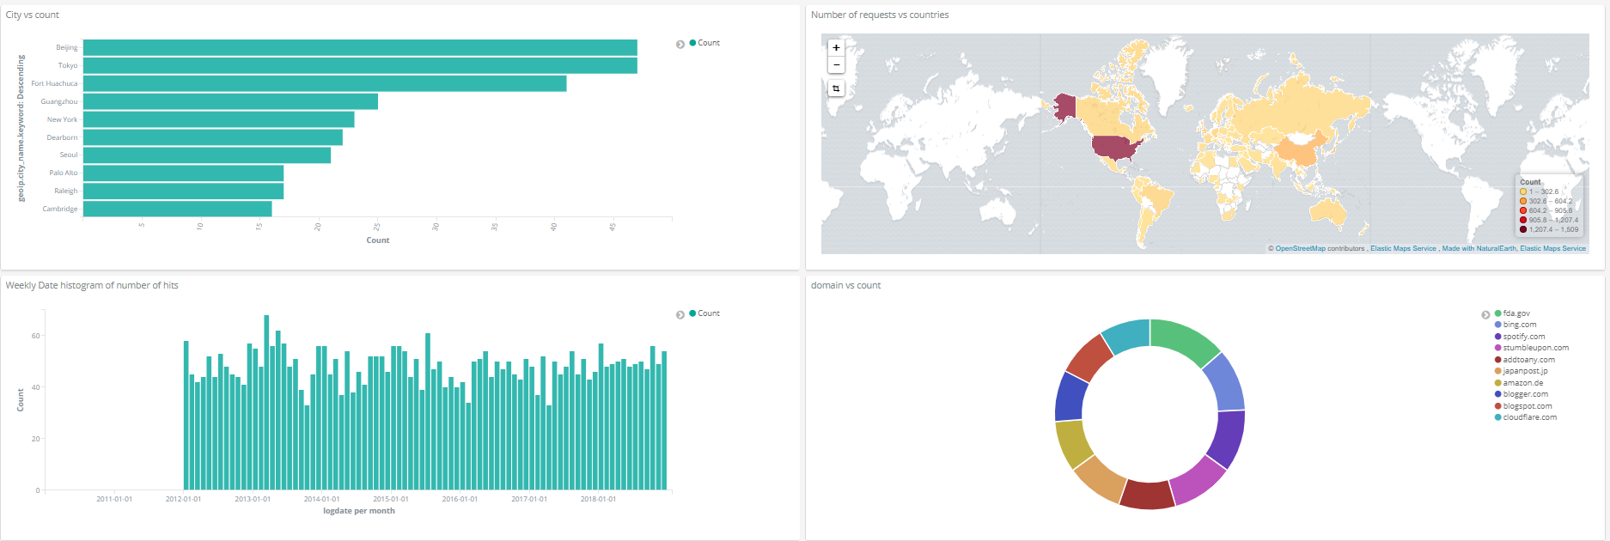

Top 10 Cities using the application.

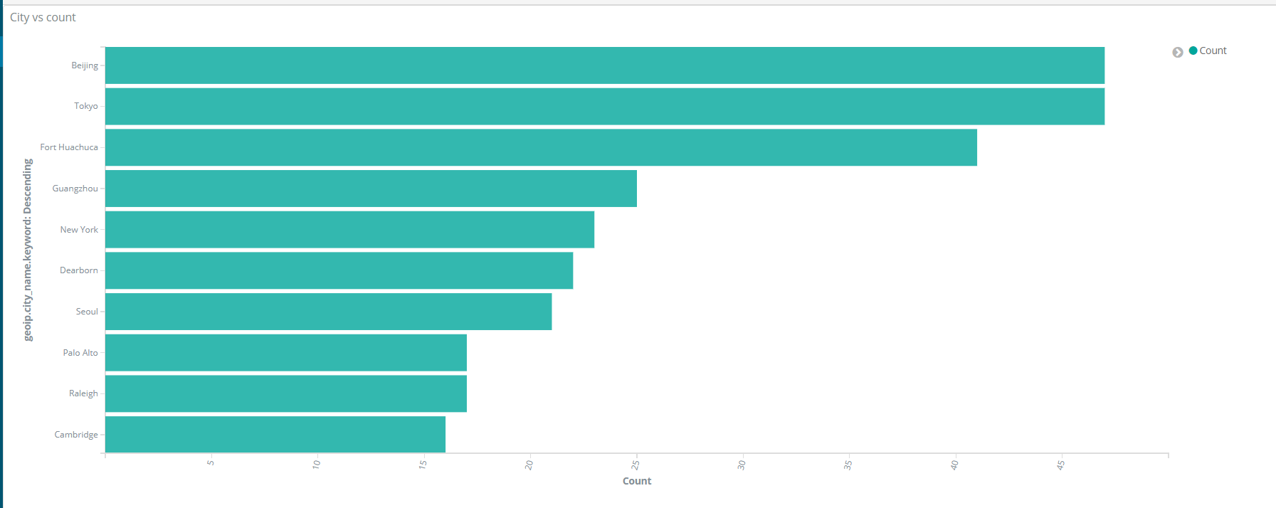

A choropleth representing the count of request in each country.

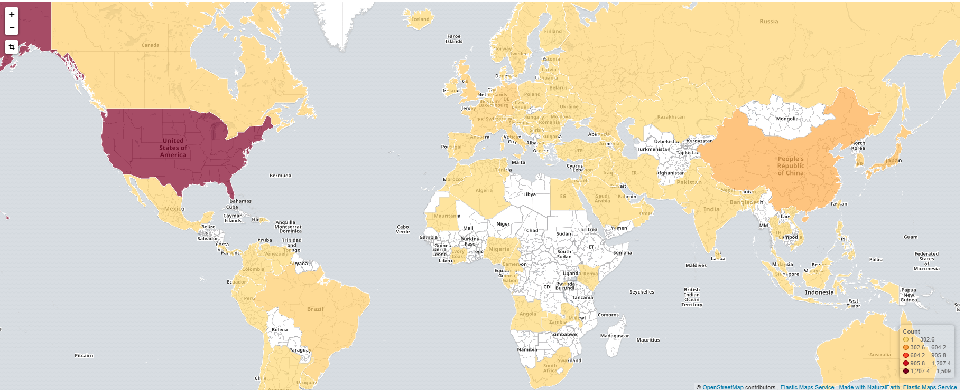

A timeline of number of request every week since the start of the application.

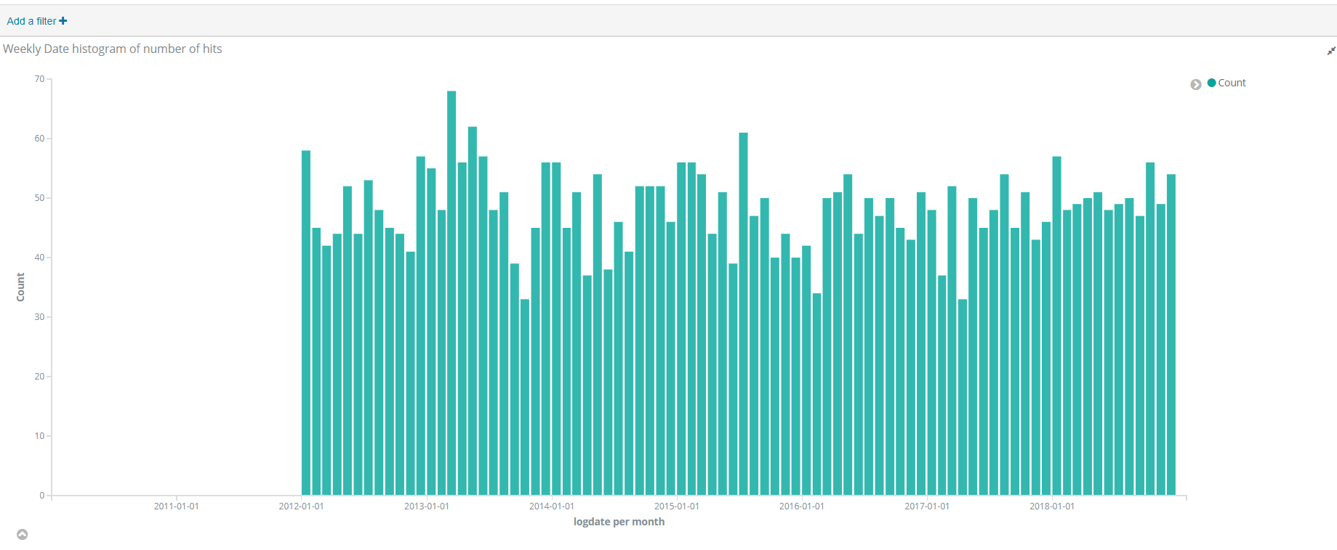

A pie chart representing the top domains whose long url has been shortened in the site.

